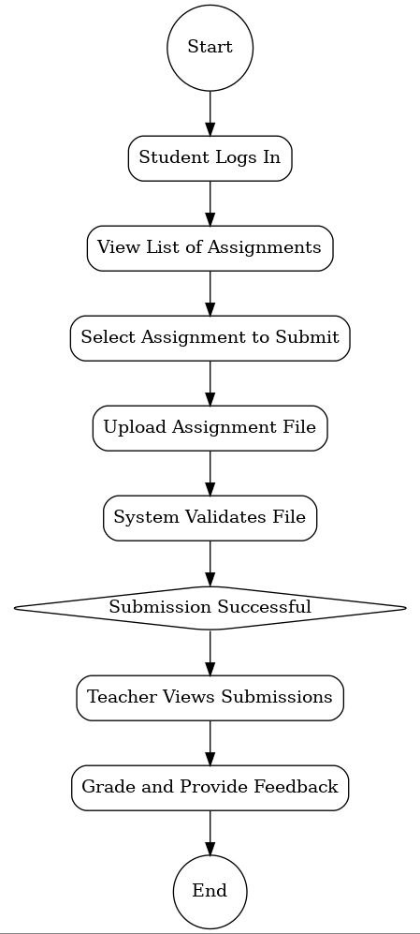

Activity Diagram

### **Actors and Activities**

1. **Students**
   1. **Submit assignments** through the platform, with features for uploading files and tracking deadlines.
   2. **View grades** and detailed feedback in real time, along with visual progress reports.
   3. **Access educational resources**, such as lecture notes, multimedia, and assignments, in one centralized location.
   4. **Communicate with teachers and peers** via messaging systems, discussion boards, and group chat for collaborative projects.
   5. **Track academic performance** with personalized dashboards showing progress and insights.
2. **Teachers**
   1. **Upload and organize class materials**, including lecture notes, assignments, and multimedia resources.
   2. **Grade assignments and provide feedback**, using tools for structured grading and performance metrics.
   3. **Monitor student performance** through detailed analytics and class-wide reports to identify areas of concern.
   4. **Send announcements and updates** to students regarding schedules, policies, or other critical information.
   5. **Foster discussions** using moderated forums and facilitate group collaboration.
3. **Administrators**
   1. **Manage platform users** by creating accounts, assigning roles (Student, Teacher), and handling suspensions or changes.
   2. **Oversee platform usage** through analytics, including tracking activity, resource utilization, and overall adoption metrics.
   3. **Ensure policy compliance** by enforcing academic and institutional guidelines.
   4. **Broadcast announcements** across classes or departments for institutional updates or policies.
   5. **Customize and scale** platform features to meet specific institutional needs.

